Title: Powerful Forces

Writer: Sharon Hill, Art Teacher

Grade Level: K-3

Related Concepts: Environment, Force, Movement

Subject Areas: English Language Arts, Science, Visual Arts

Essential Question: What are natural forces and how do they impact us?

Abstract: Students explore natural forces and their impact on living creatures through group discussion, art making and story writing. Movement as a design element is explored and applied.

Duration: Two to four class periods

Focus Works of Art:
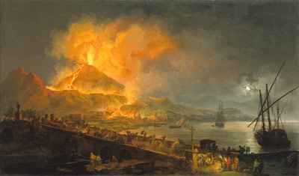
Pierre-Jacques Volaire (French, 1729–before 1802)
The Eruption of Mt. Vesuvius, 1777

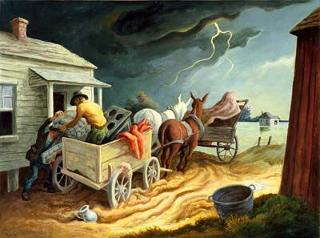
Thomas Hart Benton (American, 1889–1975)
Spring on the Missouri, 1945

North Carolina Standards Correlations
Visual Arts
K.V.3.3, 1.V.3.3 , 2.V.1.5, 2.V.3.3, 3.V.1.5, 3.V.3.3, 3.CR.1.1

Science
K.E.1.1, 1.P.1.3, 3.P.1.1

English Language Arts
K.W.3, 1.W.3, 2.W.3, 3.W.3

Instructional Objectives
- A variety of natural forces and their impact on living creatures will be investigated through group analysis of works of art, class discussion and independent art and story creation.
- Movement as an element of design will be explored through visual analysis and art making.

Student Learning Objectives
- The student will explore a variety of natural forces and demonstrate deeper understanding of one force of his/her choosing.
- The student will explore human responses to natural forces.
- The student will identify movement in a work of art.
- The student will incorporate movement in a work of art of his/her own design.

Activities
1. Explore the term force as a class through discussion and example. (You may use a bowling pin and ball to demonstrate the impact of force on a still object. Use different types of balls if you wish to demonstrate different speeds and impact.) Describe the action of forces and the changes that action brings about. Ask students to help you brainstorm a list of forces that occur nature (rain, wind, fire, etc.). Make a second list of the outcomes that often result from these forces (floods, power generation, movement of plants and seeds, etc.). Discuss ways students might measure these forces (wind speed, rain fall, temperature).

2. Discuss the focus works of art with students. Why are the people moving? What is making them flee the scene? How do natural forces impact (or change) the environment, humans and other creatures? Ask students to look for examples of movement in the works. What did the artists use to show the movement caused by these natural forces? Ask students to describe the events that precede the moment depicted in each painting and what is about to happen in the scenes.

3. Using collage materials (torn paper, yarn scraps, etc.) and crayons/markers, have students create a multimedia artwork that helps them explore one natural force and the movement associated with it. How could they best show this natural force at work? What would it look like? (If necessary, have students research photographs of natural forces at work.) Would the student be in the picture? Would there be other people in the picture? Or, would there be some kind of object, such as a tree, car, ship, house? How would they respond to the force? What movement would be occurring?

4. Students will write and illustrate a descriptive paragraph about a superhero who possesses the powers of the natural force they selected in step 3. They will describe the way that superhero impacts the people and places around him/her.

Assessments
- Participation in group discussion, collage and superhero story will demonstrate student’s understanding of forces.
- Participation in group discussion, collage, and superhero story will demonstrate student’s ability to identify human responses to forces of nature.
- Participation in group discussion of work of art will be used to assess student’s ability to identify movement in a work of art.
- Collage and story illustrations will demonstrate student’s ability to incorporate movement into a work of art.

Lesson Resources

Vocabulary:
Collage: an image or composition made by gluing onto a flat surface fragments of cut or torn material, such as various types of paper or cloth, to which drawn or painted elements may be added

Force: general definition—strength, power, intensity of effect;
Scientific definition—a push or pull between two objects

Landform: a physical feature of the earth’s surface, such as a hill or plain

Movement: a change of place, position or posture; in painting or sculpture: the quality of conveying an impression of action or motion.

Materials:
ball and bowling pin
collage materials (torn paper, yarn scraps, etc.)
crayons/markers

Links:

[links to object pages for Eruption of Mt. Vesuvius and Spring on the Missouri]

Art Rubric
http://www.goshen.edu/art/ed/rubric2.html

International Museum of Collage
http://collagemuseum.com/

Mount Vesuvius in Eighteenth-Century Art
http://www.getty.edu/art/exhibitions/grand_tour/t5_naples.html

Mt. St. Helens
http://www.mountsthelens.com/video.html

Art and Nature background information

