www.artnc.org

Writing About Art

Writer: Jill Taylor, NCMA Educator
Grade Level: 9–12
Related Big Picture Concepts: Communication, Function
Subject Areas: English Language Arts, Visual Arts
Essential Question: How do words and images influence each other?
Abstract: Students will explore the interplay between words and images through a game and image and text pair examples. They will write and revise a text reaction to a work of art.
Duration: 3–4 class periods
Focus Works of Art:
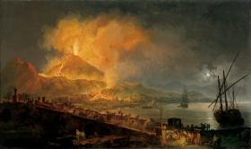
Pierre-Jacques Volaire (French, 1729-before 1802)
The Eruption of Mt. Vesuvius, 1777
Oil on canvas
53 1/8 x 89 in. (134.9 x 226.1 cm)
www.artnc.org/node/319

North Carolina Standards Correlations:
Visual Arts: B.CX.1.2, B.CX.1.3, B.CX.2.2, I.V.1.4, I.CX.1.4, I.CX.2.2, P.V.1.2, P.CX.1.4, P.CX.2.2, P.CR.1.1, A.CX.1.1
English Language Arts: 9.W.3, 9.W.4, 9.W.5, 9.SL.2, 9.L.3, 10.W.3, 10.W.4, 10.W.5, 10.SL.2, 10.L.3, 11.W.3, 11.W.4, 11.W.5, 11.SL.2, 11.L.3, 12.W.3, 12.W.4, 12.W.5, 12.SL.2, 12.L.3

Student Learning Objectives:
- Students will perceive and analyze how meaning is communicated in text and the visual arts.
- Students will analyze the relationship of word and image.
- Students will express reflections and reactions to print and nonprint texts and personal experience.
- Students will analyze and demonstrate how to use language concisely and effectively.

Activities:
- Prepare students for discussion about the roles of words and images in communication by playing two quick rounds of Pictionary in which students will draw clues to represent a word for the rest of the class to guess (approximately 10 minutes). Make cue cards with words to use as the clues for the game. For the first round, use five concrete terms, such as book, car, hot dog, apple, and shoe. In the second round, use up to five words that represent more abstract concepts that are more difficult to represent in pictures, such as red, velvet, beauty, courage, and guilt. Have students volunteer to draw clues for the rest of the class to guess using the board or chart paper. Rules for the game include: No writing. No spoken hints. No use of a rebus system. The player may pass on a word by passing the marker to another player but cannot contribute to the guessing afterward. The first round should move quickly, while the second round may take longer. For this reason you may choose to use fewer words for the second round.
- Following the Pictionary activity, ask students to compare the differences in the rounds of the game. Ask:
What were the differences between the two rounds? (types of words, easier first round, more difficult to guess in second round)
What were the challenges of communicating using only pictures?
What are different ways that words and pictures communicate? What inferences can you make about the relationship between words and pictures based on the experience of playing the game? How do words and pictures work together?
What do pictures do best?
What do words do best?
For the students who drew, how did you decide what to draw for the clue? Why?
- Inform students that they will be writing about a work of art and introduce Pierre-Jacques Volaire’s Eruption of Mount Vesuvius. Ask students to reflect on the following questions in their writing journal:
What are your first impressions of this image?
How does looking at it make you feel? What do you see that makes you feel that way?
What reaction do you think the artist was trying to provoke?
What would you like to know about this image?
If you could write a label for this work of art that evokes your experience with it in 100 words, what would that label say? What is the best way to communicate that experience?
- Provide students with a copy of the entry in the Museum’s Handbook of the Collections for this work of art:
This amazing mountain continues to exhibit such various scenes of sublimity and beauty at exactly the distance one would choose to observe it from—a distance which almost admits examination and certainly excludes immediate fear. When in the silent night, however, one listens to its groaning, while hollow sighs, as of gigantic sorrow, are often heard distinctly in my apartment, nothing can surpass one’s sensation of amazement.
This description of Mt. Vesuvius was written in 1786 by Hester Thrale, one of many travelers who made Naples and Mt. Vesuvius a destination on their tour of Europe. The picture was painted for Henry Blundell, who visited Naples in 1777 on his Grand Tour of Italy. The Grand Tour, popular among wealthy Englishmen during the eighteenth century, was an extended sojourn through Europe to admire classical ruins, picturesque landscapes, and artistic masterpieces, undertaken in order to complete their education. Volaire painted more than thirty scenes of Mt. Vesuvius, among the principal natural attractions of the continent because it erupted periodically throughout the century.

Volaire contrasts the moods of nature; the cool, calm water reflecting moonlight and fire is juxtaposed to the violent explosion and fiery terror. Along the bridge he includes references to St. Januarius, protector of Naples from volcanic destruction: from left to right are a statue of the saint, a fleeing townsman holding an image of the saint toward the mountain, and people praying before a drawing of the holy figure posted to a stone pier.
Then ask:
How does this label communicate? What does it tell you about the painting? How are words used to tell you about the painting?
Compare the styles and purposes of the two sections. What types of writing are contained in this label? How does each section function or communicate information?
How does the information in the label change the way you look at the painting?
How did it answer questions that you had about the image?
Which experience did you prefer—looking at the image without text or looking at it after you read the label?
Expand the discussion on writing about art using the background information provided [see below].
- Then select additional works of art for students to write about for an experience-based 100-word entry. Refer to the questions in Step 3 to give the ideas for how to respond. Possible choices include:
John Beerman, Three Trees, Two Clouds
Frederick Carl Frieseke, The Garden Parasol
Jacob Lawrence, Forward
Andrew Wyeth, Winter 1946
Anselm Kiefer, Untitled
Thomas Moran, "Fiercely the red sun descending/Burned his way along the heavens"
- Have students put aside their writing briefly to look at pairings of words and images in a different context: newspaper articles about events and photo captions. Select an image and accompanying article about an event such as a game or celebration from a local paper. Present the article and the image without its caption. Discuss how the article and the image work together to convey the happenings and experience of the event. What kinds of information do the article and images communicate about the game? (e.g., for a sporting event: statistics, quotes, incidents from the game, comments about the officiating or crowd) Focusing on the image, ask:
What is going on in this picture? What do you see that makes you say that?
What additional information would you like to know?
What would help you feel like you were at the event or watched it?
Show students the caption for the image. Ask:
What does this caption add to your experience of looking at the picture?
How are the caption and image connected?
What other info might help us understand these images better?
As a class, discuss ways that the caption could be made more effective. Have a student write the class’s suggestions for improving the caption on the board.
- Have students revisit the 100-word writing completed in the journals for Step 5. Instruct them to revise their writing to a caption length of one to two sentences; the caption should evoke their experience of viewing the work of art rather than describing the image. Have students reflect in their journals on the process of revising their original text into a much shorter form.
- As a class, create an exhibition catalogue of the images with the student captions.

Assessments:
  - Game playing, followup discussion, and the newspaper activity will be used to evaluate students’ understanding of how images and language communicate meaning and the interconnectedness of word and image.
  - Journal entries and the caption will demonstrate the students’ ability to articulate and revise personal reflections.

Lesson Resources:
Newspaper Web sites: www.newsobserver.com, www.charlotteobserver.com, www.news-record.com
Writing about Art:
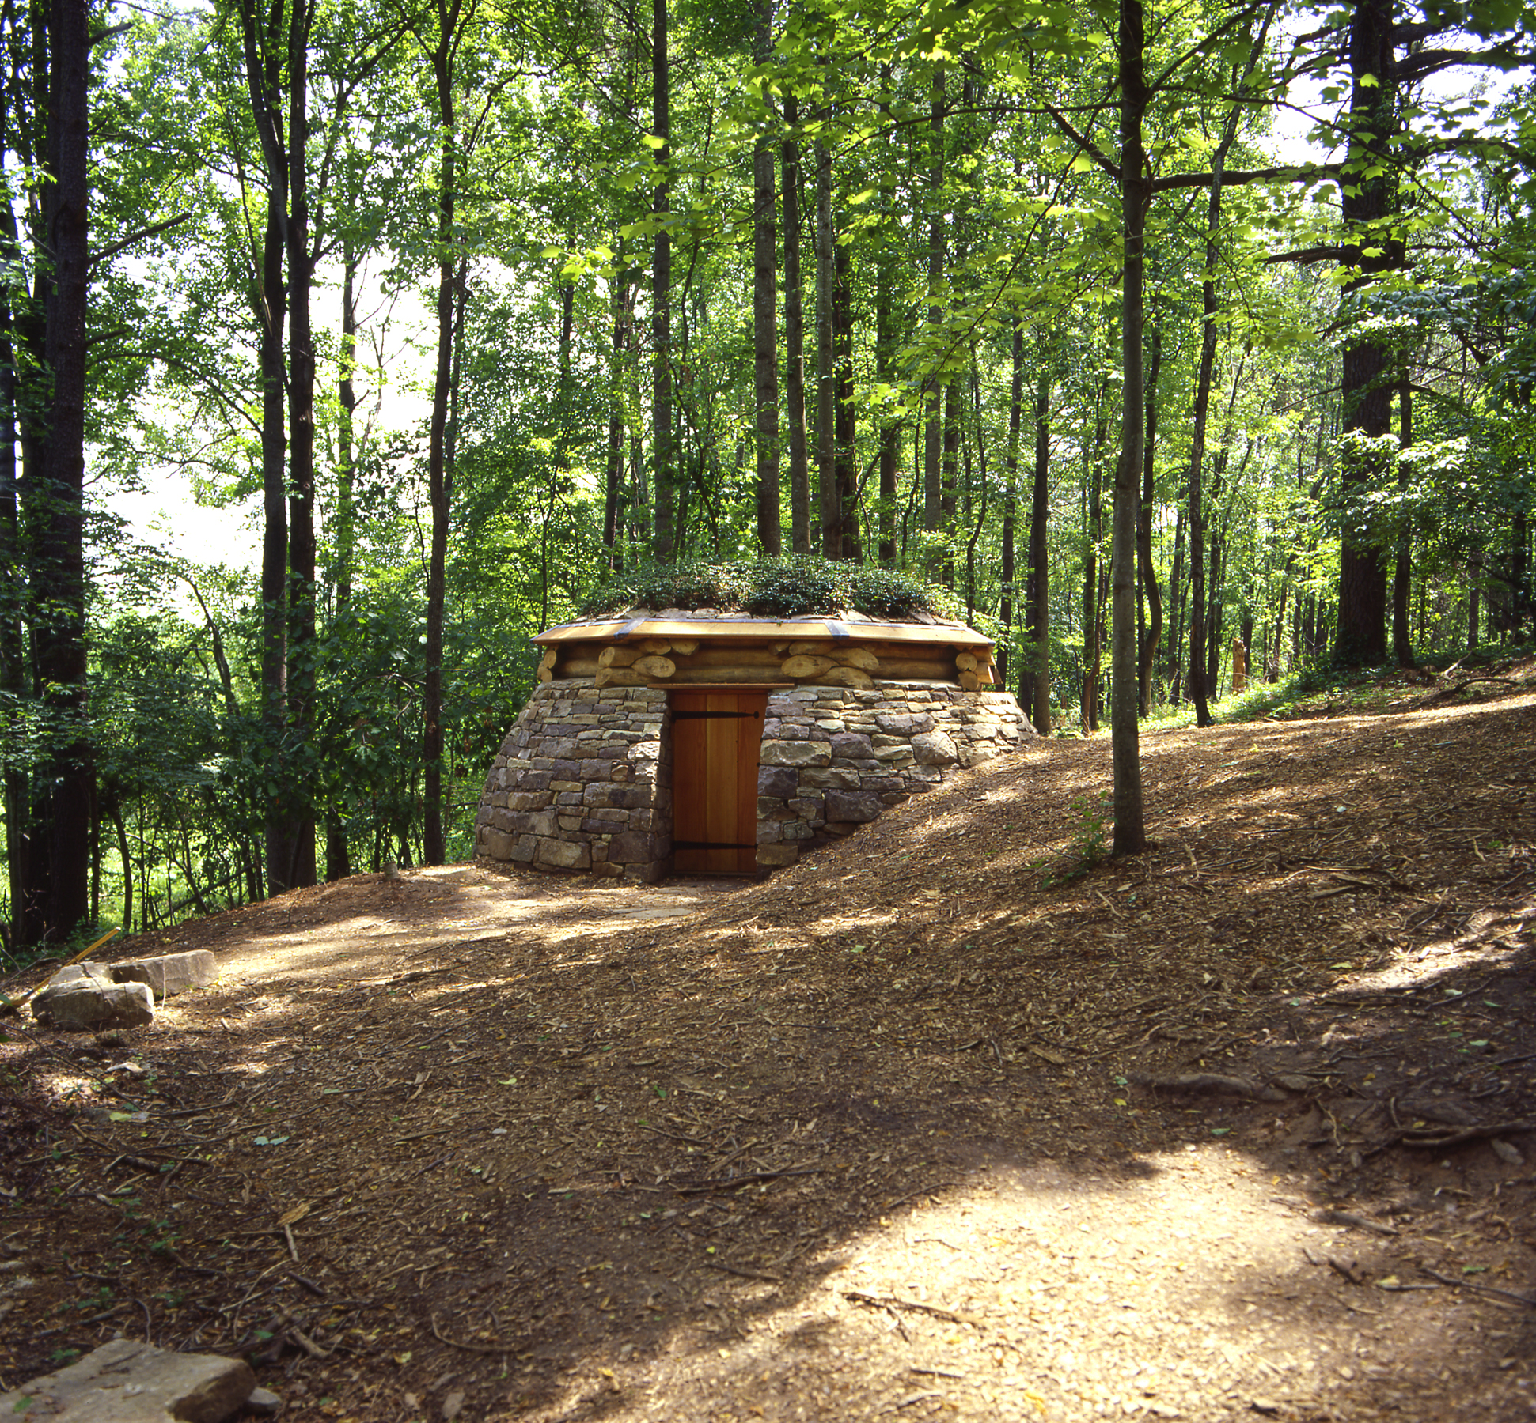
Chris Drury, Cloud Chamber for the Trees and Sky, 2003

How many ways can you describe a work of art?
Drury chose a wooded area of the Museum Park as the site for one of his cloud chambers. This permanent structure is approximately 12 feet in diameter and is built of dry stone. Notched logs make up an octagonal roof that is covered with turf and groundcover.
Compare this description to the image above. What does the image tell us that the words do not? What do these words tell us about the Cloud Chamber that the image does not? What purpose do both serve? After seeing the image and reading the text, what more would you like to know? The presence of a door in the structure might make us wonder what the inside of the space looks like. An image of the interior appears below.
[interior view]
What happens inside this work of art? Here is one description:
There is a small aperture about the size of a quarter in the middle of the roof that allows light to pass through. When the door is closed, only scattered light from the sky and reflected light from the trees travels through the aperture into the chamber. The reflection of these rays off the white surface of the walls and floor forms a clear, inverted image. Clouds and sky appear on the floor of the room, and trees appear upside down on the walls.
What type of description is this? What does it describe? The description tells us what type of image appears inside the Cloud Chamber when light passes through the aperture. Using a straightforward and practical manner, it describes what people see when they enter the Cloud Chamber and close the door.
Compare the description to this:
The Cloud Chamber functions much like our eyes do. Light reflecting off objects around us enters our cornea and is projected onto our retina, inverted and reversed, by the lens. This information is sent to the brain, where it is translated into vision.
How does this text work with the passage above? It adds some information about the process of how we see the images inside the Cloud Chamber. It explains how it works.
When does language fall short of describing a work of art?
What happens to the person who sees this work of art? This question has as many possible answers as the Cloud Chamber has possible viewers; the description above is just one possibility. It was written to describe what a person will see inside the Cloud Chamber and compare how the aperture works to the eye; it explores connections between science, nature, and art; the description is appropriate for the purpose of the text.
What element of the viewer’s experience is left out of this description? Here are some questions that come to mind that could help describe what is missing: What does it feel like inside the Cloud Chamber? For example, is it warm or cool? How long does it take for your eyes to adjust? How clearly do you see the trees and the sky on the walls and the floor? How does it feel to see the trees and the sky on the walls and the floor? What thoughts go through your mind while you are inside? What happens if your thoughts go quiet and you cannot put your experience into words?
When we discuss a work of art or write about it, we impose a verbal structure on an experience that is not always mediated by words. Art has the power to provoke an emotional response; it can make us laugh or cry. Inside the cloud chamber, people may feel disoriented, meditative, or a combination of emotions. An Italian doctor wrote a book about a phenomenon called the Stendhal syndrome, in which visitors to Florence experienced symptoms of illness during and after their experiences of looking at art. Many scholars were able to provide other reasons for the physical symptoms of the patients, but the people who went to the doctor linked their experiences with art to their illness. What does this tell us about the ways an experience with art can affect us?
When does writing have a power similar to a work of art?
What have you read that made you laugh or cry? What type of writing was it? The Roman philosopher Horace wrote, “Ut pictura poesis,” which means as is painting, so is poetry. Figurative language, such as metaphor, can provoke reactions from readers that mirror the reactions people have when they look at art. Writers can translate experiences into novels or poetry for their readers to identify with and make their own. Powerful writing is not the exclusive domain of creative writing—expressive essays, journalism, and solitary journal writing can capture feelings experienced by individuals and groups. How would you write to make a person “see” your experience with a work of art?

