www.artnc.org

Images and Sounds

Writer: Zoe Voigt, Humanities Teacher
Grade Level: 9–12
Related Big Picture Concepts: Meaning, Place
Subject Areas: American History, Social Studies, Visual Arts
Essential Question: What is abstract painting, and can it be linked to place and sound?
Abstract: Students will learn about abstract painting through brainstorming and create their own work of art while listening to improvisational music.
Duration: 2–3 class periods

Focus Works of Art:
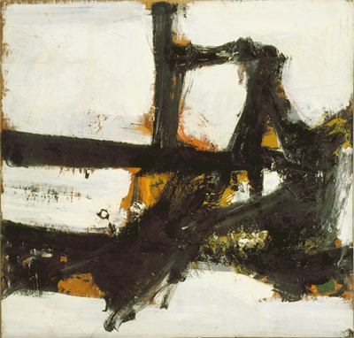
Franz Kline (American, 1910 - 1962)
Orange Outline, 1955
Oil on paperboard mounted on canvas
3ft 2in x 3ft 4in (96.5cm x 1m 1.6cm)
www.artnc.org/node/439
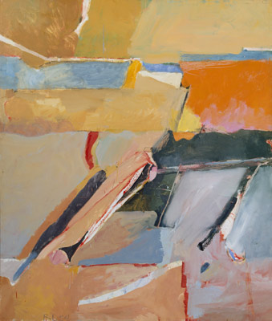
Richard Diebenkorn (American, 1922 - 1993)
Berkeley No. 8, 1954
Oil on canvas
5ft 9in x 4ft 11in (1m 75.3cm x 1m 49.9cm)
www.artnc.org/node/404

North Carolina Standards Correlations:
Visual Arts: I.V.1, I.V.2, I.V.3, I.CX.1, I.CX.2, I.CR.1, A.V.1, A.V.2, A.V.3, A.CX.2
United States History: USH.H.1.2, USH.H.4.4

Student Learning Objectives:
- Students will understand the historical context of abstract expressionism and jazz in the context of an urban environment.
- Students will explore how a sense of place can be evoked in both visual and musical imagery.
- Each student will interpret abstract art and make a painting that corresponds with the art and music.

Activities:
- Assign the class to examine Orange Outline and Berkeley No. 8.
- Conduct a brainstorming session in which students provide one-word descriptions or adjectives that come to mind as they view the Kline and Diebenkorn paintings. Write the words on the board in no particular order.
- Hold a brief class discussion focusing on grouping the words from the brainstorming exercise into categories. Ask students to think of a category and then select the words that reflect that category. How do these categories and words relate to the painting? How did the artist create those references? What specific elements of the works of art helped you generate these words?
After the initial discussion of the words, direct the students to consider the following questions about place: What kinds of places do these works remind you of? What do these two works tell us about urban and rural environments? What do the works tell us about their time periods? What kinds of sounds do you associate with the two environments?
Briefly discuss the connection between urban environments and abstract expressionism using the background material on abstract expressionism.
- Have the students read the New York Times article about the music of Morton Feldman and his relationship to abstract expressionism.
- Play the YouTube video “For Franz Kline” by Morton Feldman, and discuss the relationship between the paintings and the music.
- Assign students to paint two images: one based on their interpretation of or feelings about Kline's Orange Outline and one based on their interpretation of or feelings about Diebenkorn's Berkeley No. 8. Replay the song “For Franz Kline” by Morton Feldman while they work. Direct students to incorporate aspects of place into each of their works. Ask for volunteers to discuss their paintings with the class and explain how they used the music and the two Museum paintings for inspiration.

Assessments:
- The teacher will use the brainstorming and group exercise, class discussion, and the painting to assess the students’ analysis of the abstract works of art and their relationship to sound and place.

Resources:
Vocabulary:
abstract
expressionism
improvisation
interpretation
inspiration
landscape

Materials:
paper, paints, and paintbrushes

Links:
Information on Abstract Expressionism from Metropolitan Museum of Art
http://www.metmuseum.org/toah/hd/abex/hd_abex.htm

New York Times Article about the music of Morton Feldman
http://www.nytimes.com/1996/07/28/arts/classical-view-the-abstract-expressionist-of-music.html?src=pm

Connection between urban environments and Abstract Expressionism
http://education.moma.org/moma/learningresources/cms_page/view/366531

Morton Feldman recording of “For Franz Kline” on YouTube
http://www.youtube.com/watch?v=DDuGj80TrVE

For information on the connection between music and abstract expressionism:
“Imaging Music: Abstract Expressionism and Free Improvisation” by Matthew Sansom
Leonardo Music Journal Vol. 11, Not Necessarily "English Music": Britain's Second Golden Age (2001), pp. 29–34

Additional Resources:
Fairbrother, Trevor, and Potts, Kathryn. In and Out of Place: Contemporary Art and the American Social Landscape. Boston: Museum of Fine Arts, 1993.

Hughes, Robert. American Visions: The Epic History of Art in America. New York: Alfred A. Knopf, 1997.

Menkes, Diana, ed. Of Time and Place: American Figurative Art from the Corcoran Gallery. Washington, D.C.: Smithsonian Institution Press, 1985.

Wilmerding, John. American Masterpieces from the National Gallery of Art. New York: Hudson Hills Press, 1980.

